DOTY ISLAND RUMMAGE SALES – SATURDAY, JUNE 14, 2018 – 8AM TO 2PM
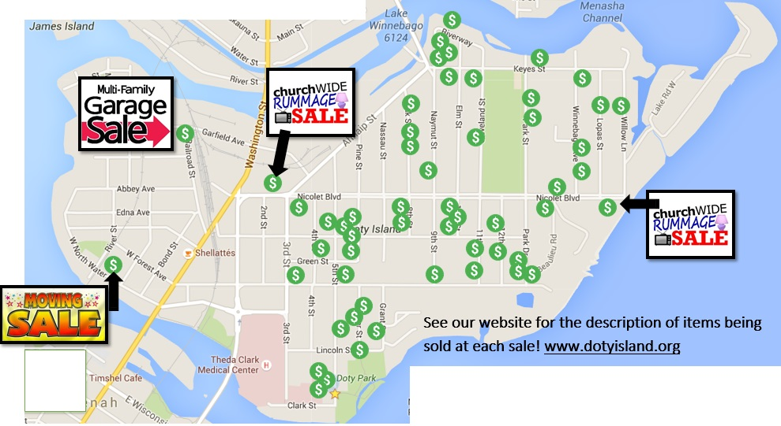

DOTY ISLAND RUMMAGE SALES – SATURDAY, JUNE 14, 2018 – 8AM TO 2PM
NEENAH RUMMAGE SALES MENASHA RUMMAGE SALES

4th Street 343 Cleveland Street 311, 397 ​
5th Street 116, ​120, ​124, 243, 428 Keyes Street 510, 515, 726​
​​6th Street 322, 416 Lopas Street 336 - Downsizing!
​8th Street 412, 424 Naymut Street 407
​10th Street 409, 499 Oak Street 316, 332, 336
​11th Street 320, 332, 418 Railroad Street 225
​12th Street 328, 421 Riverway 507, 519, 540
​Beaulieu Road 430, 442 Willow Lane 341 ​
​E. Forest Avenue 402, 620, 1002 Winnebago Avenue 300, 370, 384
Grant Street 236
​Hewitt Street 604, 702
​Lincoln Street 621
​W. North Water St. 323 - Moving sale!
​Nicolet Blvd 417, 1017, 1511 – Church Sale!​ Nicolet Blvd 748, 312 - St. Pat’s Church Sale!
Park Drive 333, 337 Park Street 328, 346 ​
​Webster 220, 229

NEENAH RUMMAGE SALES MENASHA RUMMAGE SALES

4th Street 343 Cleveland Street 311, 397 ​
5th Street 116, ​120, ​124, 243, 428 Keyes Street 510, 515, 726​
​​6th Street 322, 416 Lopas Street 336 - Downsizing!
​8th Street 412, 424 Naymut Street 407
​10th Street 409, 499 Oak Street 316, 332, 336
​11th Street 320, 332, 418 Railroad Street 225
​12th Street 328, 421 Riverway 507, 519, 540
​Beaulieu Road 430, 442 Willow Lane 341 ​
​E. Forest Avenue 402, 620, 1002 Winnebago Avenue 300, 370, 384
Grant Street 236
​Hewitt Street 604, 702
​Lincoln Street 621
​W. North Water St. 323 - Moving sale!
​Nicolet Blvd 417, 1017, 1511 – Church Sale!​ Nicolet Blvd 748, 312 - St. Pat’s Church Sale!
Park Drive 333, 337 Park Street 328, 346 ​

